Consultation “Menu”
Chapter
This is your opportunity to develop the consultation to fit the needs of your chapter. The consultant is able to facilitate the following meetings, upon your request, to help improve the chapter.
Additional Officer Meetings – Place an X next to the officer if you would like the consultant to meet with any of the following:

☐- Social Chairman
☐- Alumni Relations Chairman
☐- House Manager
☐ - Other: Insert Title
☐ - Other: Insert Title
☐ - Community Service & Philanthropy Chairman
☐- Helping Hand Initiative – Assess your chapter’s current service and philanthropy plan and develop any needed improvements (45 min. with Community Service and Philanthropy Chairman and committee).

Pursuit of Excellence Program (PEP) Workshops – These workshops are designed to help your chapter improve in areas directly related to the PEP. (Choose any combination of the following by placing an “X” in the checkboxes):
☐- Pursuit of Excellence Program Strategy Session – Help your chapter develop goals and action plans for the upcoming year based on the results from your chapter’s previous PEP submission. (Ideally facilitated at the beginning of the academic year for the chapter.)
☐- What is the Pursuit of Excellence Program (PEP)? – Gain an understanding of the program, including a brief history. Learn about available resources, find out how to create an excellent submission, how submissions are evaluated, and create a plan to guide the chapter to excellence. (1 hour with entire chapter or Executive Board.)
Values-Based Leadership – Sigma Nu transforms society through the commitment of its members to the Fraternity’s founding principles, leadership and ethical living.
Values Congruent Environments

☐- To Walk in the Way of Honor – Come to a better understanding of The Ritual through a discussion of the honor principle, and how it can help us be better brothers. Learn how the honor principle can help us make all brothers and guests feel safe and reassess your chapter’s commitment to its values. (1-1.5 hours with chapter)
☐- Learn more about The Ritual, including a brief history and overview of all ceremonies. (1 hour)
☐- A Different Look at Hazing – Workshop options include a discussion on eliminating groupthink and bystander behavior, reviewing the hazing psychology and legal precedent, and properly identifying hazing and non-hazing activities. (1-2 hours with chapter depending on facilitation options)

Operational Excellence – Sigma Nu’s organizational structure and internal operations will provide for the effective deployment of resources to deliver excellence in every facet of the Fraternity.

Recruitment and Manpower
☐- Chapter-Level Recruitment – Assess and improve your chapter’s current recruitment strategy. Work together as a chapter to determine what you are looking for, self-evaluate, and set goals and practice skills to find success. Review the best skills to utilize when recruiting at the interpersonal level. Understand the purpose of using a Master Prospect List (MPL) as well as work to create the MPL that will help the chapter find success. Learn how to incorporate Sigma Nu’s VBR Program. (1.5-2 hours with chapter)
Chapter Operations
☐- Committees – Create or revamp your chapter’s committee structure and learn about the importance of delegation. (1 hour with Executive Committee)
☐- Officer Transition – Plan and implement an effective officer transition. (45 minutes with Executive Committee)
☐- Motivation – Learn the differences between motivation/morale and positive/negative vs. intrinsic/extrinsic motivation. Discuss and develop strategies to improve the motivation of your chapter members. (45-60 minutes with Executive Committee)
☐- Goal Setting – Identify the areas of needed improvement in your chapter and begin the process of establishing effective goals. Advance your chapter’s efforts by establishing a mission and vision, and developing a comprehensive plan to achieve them. (1-2 hours with Chapter depending on facilitation options)
Other Workshop or Committee Meeting (request assistance with a topic not listed above)
☐ - Other: Describe ☐ - Other: Describe

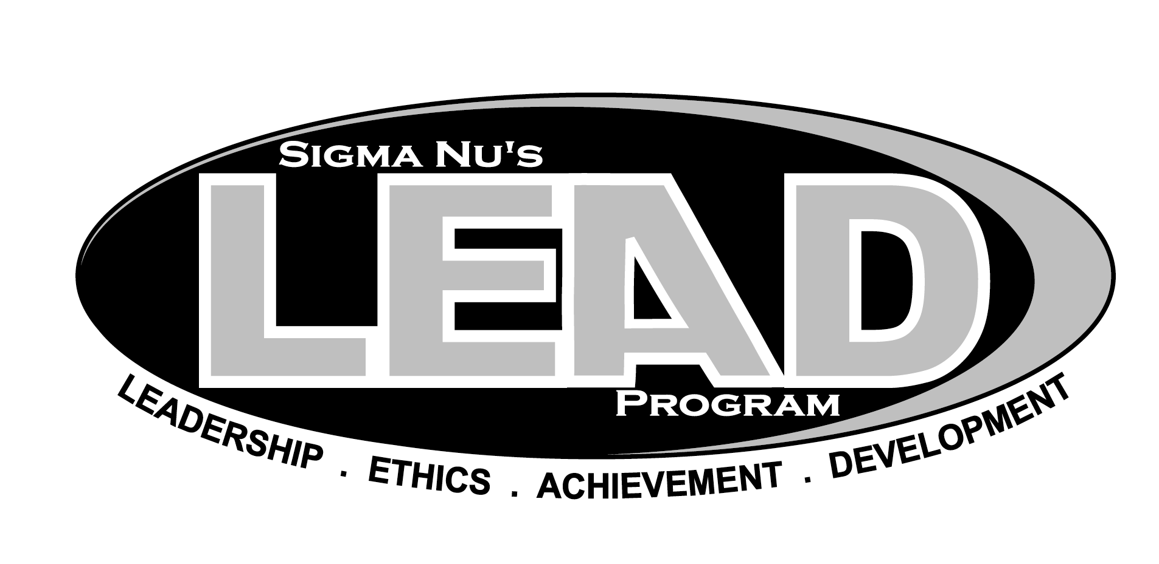
In addition to the above PEP workshops, we would like you to choose at least one of the following LEAD Sessions. These sessions include those your consultant is most prepared to facilitate. If a session not included here would be more helpful, feel free to let your consultant know in your email response to this order form.

Phase I: The Way of Honor
☐ Session 1: Fraternity
☐ Session 4: Sigma Nu: International Organization & Chapter Operations
☐ Session 5: Risk Reduction
☐ Session 8: Leadership: The Basics
☐ Session 10: Ritual: The End...The Beginning
☐ Session 11: Community Service
Phase II: The Life of Love
☐ Session 3: Visionary Leadership
☐ Session 4: Effective Change
☐ Session 7: Controversy with Civility
☐ Session 8: Living Our Values

Phase IV: The End… The Beginning
☐ Session 3: Servant Leadership
☐ Session 5: Conflict
All-Chapter:
Module A: Personal Development
☐ Session 6: Diversity
Module B: Chapter Operations
☐ Session 2: Delegation
☐ Session 3: Effective Meetings
☐ Session 7: Accountability
Other LEAD Session (not listed above)
☐ - Other: Specify Session
☐ - Other: Specify Session

Leadership consultants are also equipped to offer teambuilding services to the chapter. This might include facilitating team and brother-building activities for the chapter, a committee, or candidate class. Consultants can also teach one or more officers how to facilitate and select teambuilding activities for incorporation in chapter operations (e.g. candidate education, officer transitions, recruitment, social events).
Teambuilding
☐- Participate in a series of teambuilding activities. (1 hour or more, depending on chapter needs)

